Report 00.435
12 June 2000
File: CP/4/8/1

Report to the Policy and Finance Committee
from Brendan Paul, Manager Flood Protection (Strategy and Assets)
and Ian Gunn Manager, Operations, Wairarapa

Application of Flood Protection Funding Policy

1. Purpose

For the Council to adopt the proposed application of the Flood Protection funding policy, for specific flood protection and river projects and schemes, following the statutory consultation process.

2. Background

Report 00.424 presents to Council the various issues and suggested adjustments related to Council’s funding policy, identified through the statutory consultation period, and recommends its adoption for implementation. The delivery of projects or services for flood protection requires specific application of the funding policy for the various river and flood protection schemes.

Application of the funding policy for the Western Region and the Wairarapa, within the ranges identified in the policy document, are covered below.

3. Proposed Funding Policy Application

3.1 Western Region

In the period 2000 – 2010 Council proposes capital works for delivering flood protection on four schemes which are noted below. The current application of the funding policy for these schemes is for 50% of the rate to be charged to general rate and the other 50% charged as a works and services rate (river rate) on the economic catchment. It is proposed that this same application of the funding policy will continue to apply. The schemes for which this proposed application will apply are:

- The Hutt River Floodplain Management Plan
- The Otaki Flodplain Management Plan
- The Waikanae Floodplain Management Plan
- Porirua Flood Mitigation Works (Findlay Street Re-alignment)

Over the same period maintenance works are proposed over the major schemes noted above, and a number of other minor schemes. The current application of the funding policy for these schemes is for 50% of the rate to be charged to general rate and the other 50% charged as a works and services rate (river rate) on the economic catchment, or alternatively directly charged to the relevant territorial authority. It is proposed that this same application of the funding policy will continue to apply.

3.2 Wairarapa

The current funding policy for all of the schemes is 50% charged to the general rate and 50% charged to the ratepayers within the scheme. Isolated works completed outside of the schemes are eligible for up to 30% funding from the general rate with the balance being contributed by the individual or beneficiary. The attached table outlines the various schemes managed in the Wairarapa. There is widespread support from the scheme ratepayers for the current policy to remain in place. It is proposed that there be no change to the current funding policy.

4. Recommendation

- That Council adopts the application of the Flood Protection funding policy as defined in section three of this report, for delivery of works and maintenance on specific flood protection and river projects and schemes.

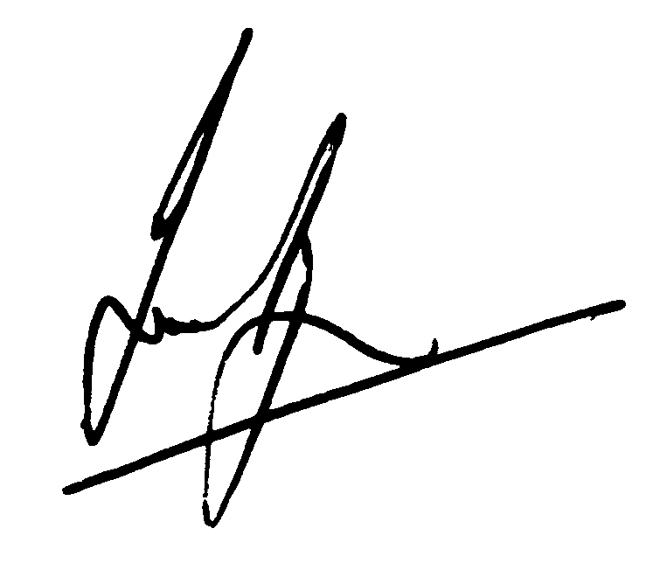BRENDAN PAUL IAN GUNN
Manager Flood Protection (Strategy and Assets) Manager, Operations (Wairarapa)

JOHN ALLARD
Manager, Corporate Advisory Services

