eMission Outline:

eMission is a 1-year subsidised programme to help businesses achieve nationally-recognised environmental accreditation (EnviroMark®-NZ Gold) and reduce their carbon footprint.

A business that joins the programme will receive:-
- Access to a Business Sustainability Advisor.
- EnviroMark®-NZ Accreditation (workshops and third-party audits for 3 levels, Bronze, Silver and Gold.)
- Energy, Transport and Waste Audits and advice on how to improve.
- Carbon emission calculation and guidance on how to reduce.
- Networking with other businesses.
- Opportunity to win the Greater Wellington Regional Council Environmental Business Award.

eMission Objectives:

Participating businesses commit to:-

1. To implement a resource efficiency programme that will:
- Reduce solid waste
- Use energy efficiently
- Use water efficiently (if an opportunity is identified)
- Use raw materials efficiently (if an opportunity is identified)

2. To implement environmental procurement policies for suppliers and contractors

3. To adhere to relevant environmental:
- accords
- best practice
- codes of practice

4. To achieve Enviro-Mark®NZ (Gold) certification.

5. To reduce carbon emissions

Ten reasons to join eMission

- Support - access to a business sustainability advisor, workshops and resources.
- Cost savings - through using resources more efficiently. Businesses receive energy, transport and waste audits and guidance on reducing their carbon footprint in these areas
- EnviroMark®NZ accreditation (workshops and third-party audits for three levels - bronze, silver and gold) - an easy to follow, staged approach to environmental accreditation
- Marketing advantage and reputation - having a point of difference from competitors and the opportunity to win recognition through Greater Wellington Environmental Awards
- Improved systems - through increasing staff awareness and participation
- Partnership and networking with other businesses
- Legal compliance - support that covers health, safety and environmental legislation
- Risk management - businesses work towards environmental best practise and go above and beyond compliance.
- Staff morale - from working for an organisation that cares about the future.
- Economical - Government and local government sponsorship subsidised the programme by approximately half.

Business Testimonials:-
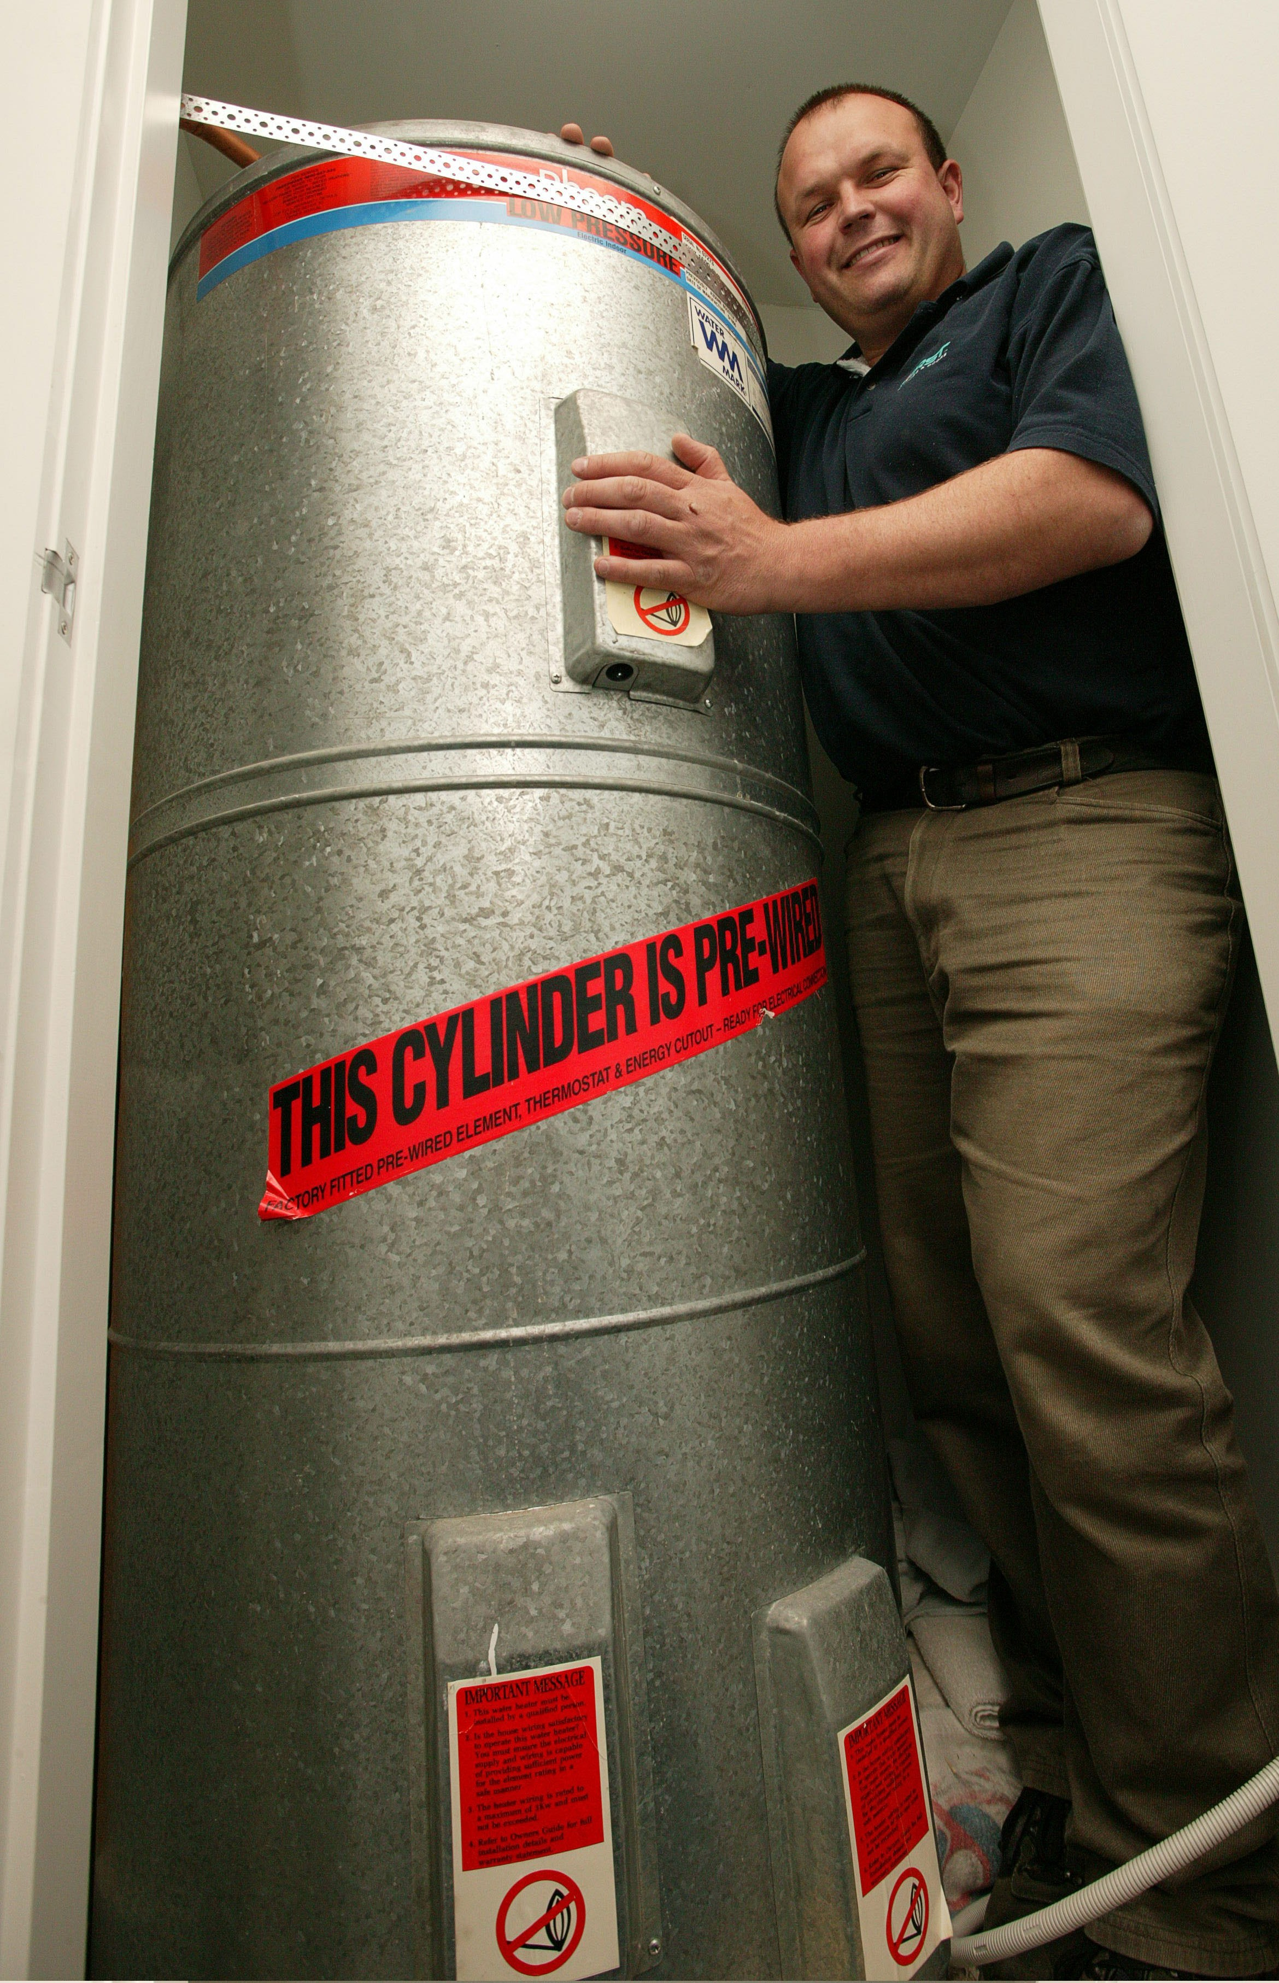
First Windows & Doors - Increased profits from becoming more resource efficient and found that the savings from energy efficiency alone will be worth the cost of the programme.

Booker Spalding - Found that by having the EnviroMark®NZ certification ranked them top of their client’s supply chain list. Most government agencies request to see environmental certification from their suppliers.

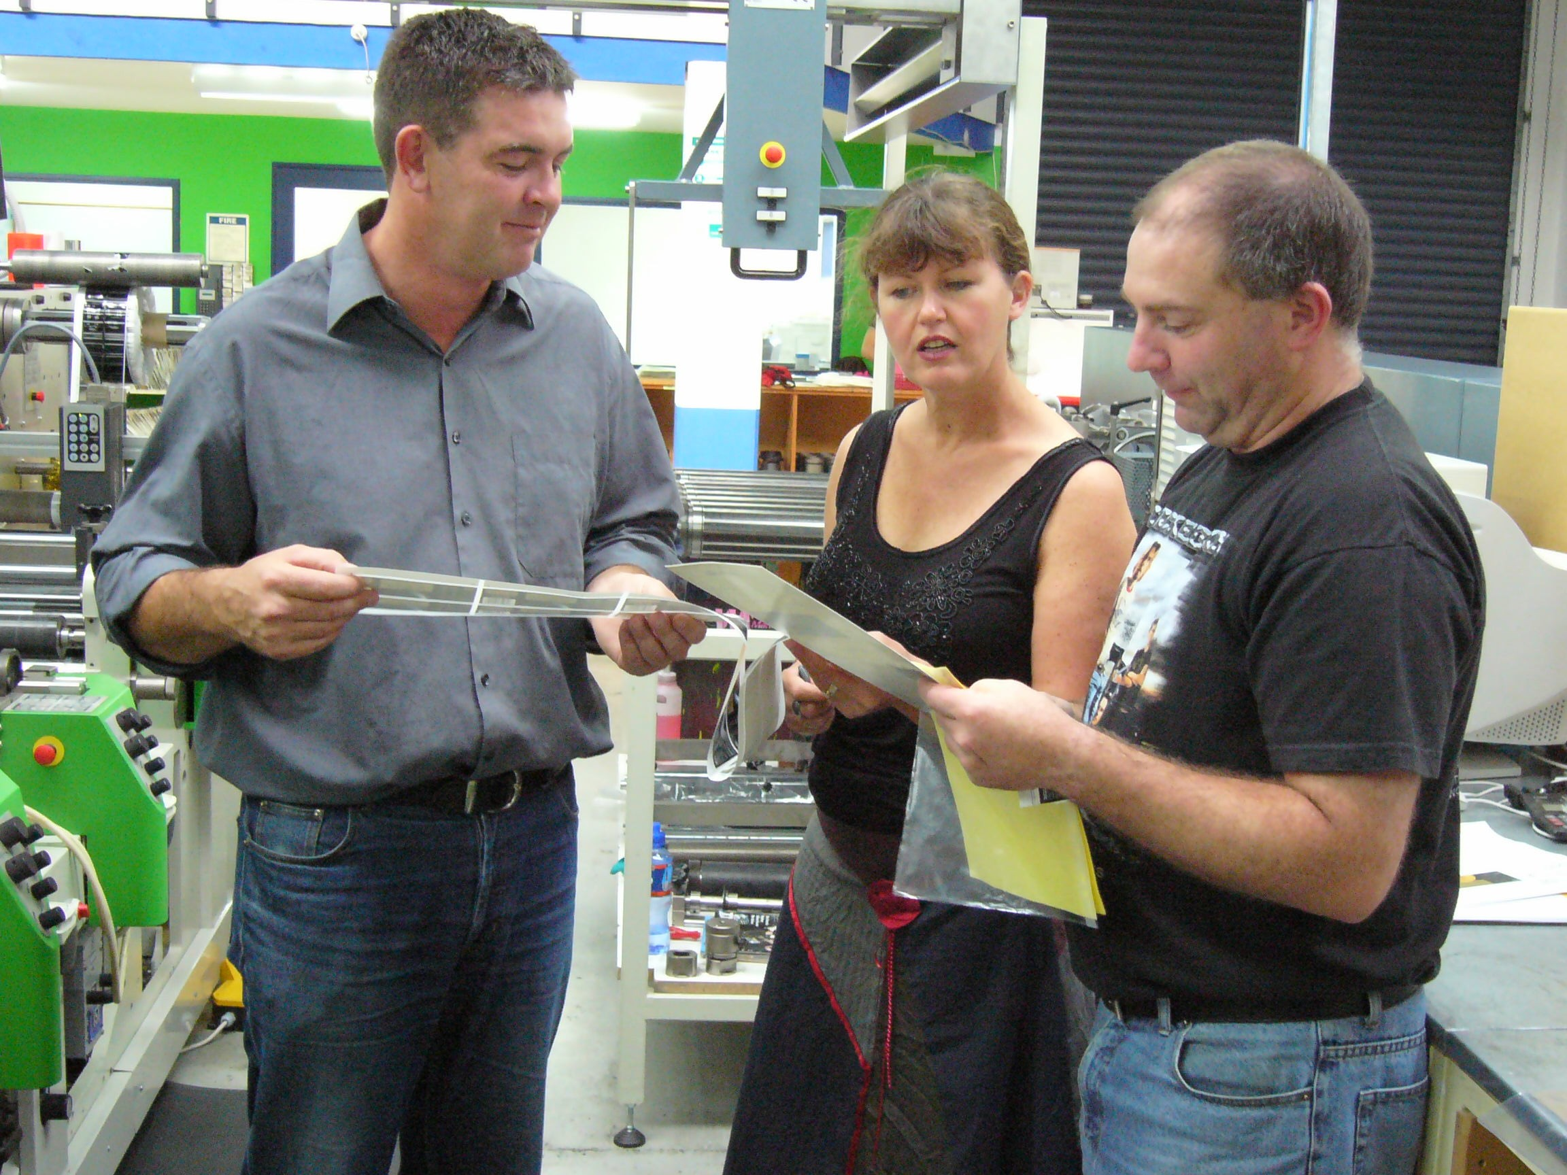
Label and Litho - Gained a competitive advantage through involvement in the programme.

Thames Publications – The company’s safety management and its safety response has substantially improved from being in the programme.

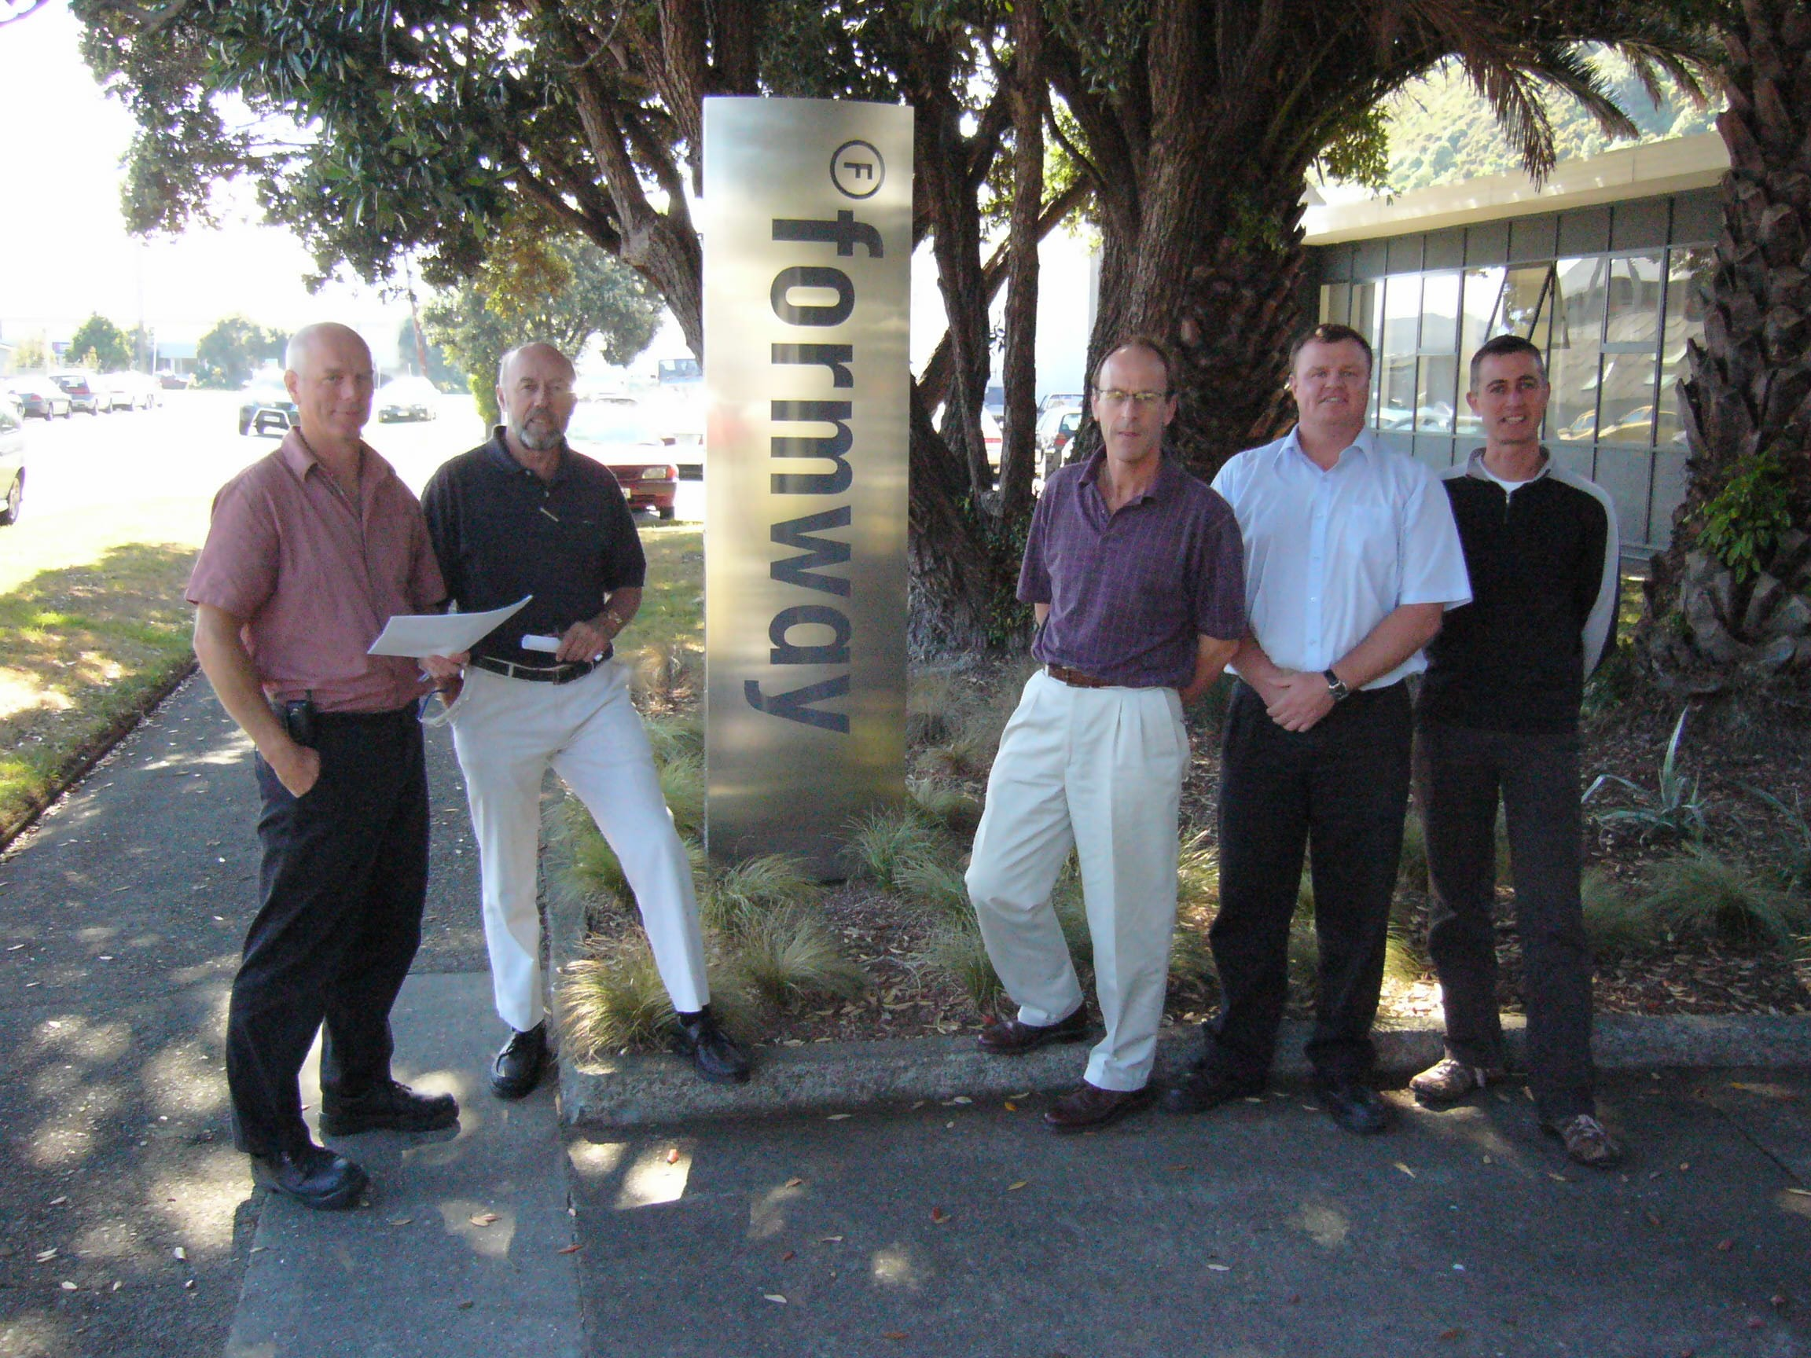
Formway Furniture – Found the programme to be an excellent phased approach to developing their Environmental Management System. By passing the third-party audits at each EnviroMark®NZ level they were able to credibly demonstrate they are taking steps to manage their environmental processes.

